**DAILY ONLINE ACTIVITIES SUMMARY**

|  |  |  |  |  |  |  |  |
| --- | --- | --- | --- | --- | --- | --- | --- |
| **Date:** | **09 June 2020** | | | | **Name:** | **Sinchana K N** | |
| **Sem & Sec** | **4th sem, 2nd year** | | | | **USN:** | **4al18cs083** | |
| **Online Test Summary** | | | | | | | |
| **Subject** | | **--------** | | | | | |
| **Max. Marks** | | **-----** | | **Score** | | **-----** | |
| **Certification Course Summary** | | | | | | | |
| **Course** | **Statistical Methods for Decision Making** | | | | | | |
| **Certificate Provider** | | | **Great Learning** | **Duration** | | | **7 hours** |
| **Coding Challenges** | | | | | | | |
| **Problem Statement:1 program** | | | | | | | |
| **Status: Executed** | | | | | | | |
| **Uploaded the report in Github** | | | | **Yes** | | | |
| **If yes Repository name** | | | | https://github.com/acchu1234sinchana/Lockdown_coding1  <https://github.com/keertanaganiga/lockdown_reports> | | | |
| **Uploaded the report in slack** | | | | **Yes** | | | |

**Certification Course Summary:** **Today i learnt Bayes Theorem,Probability Distributions and Poisson distribution**



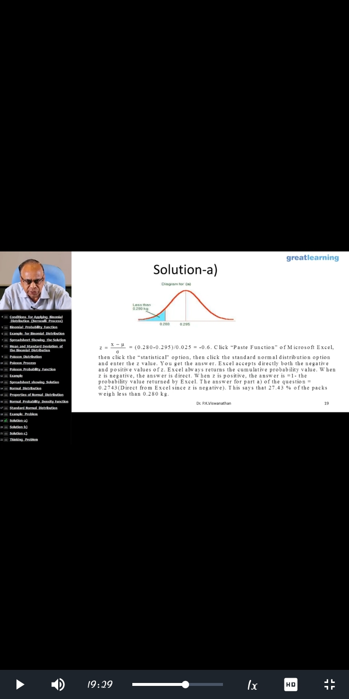

**Coding Challenges:**

Today I solved 1 coding challenge,

**1.**  **Write a C++ Program to rotate the matrix by K times Program in C**

